

 

School of Electrical Engineering and Computing Department of Computer Science and Engineering

INTERNSHIP REPORT

Interns

1. Kalid Muktar……………………………ugr/22996/13

2. Yeneineh Seiba………………….ugr/22554/13

Supervisor: Ms. AYANA

Advisor: Mr. Jiregna Abdisa

Due date : 25/10/2023

# 

# Executive summary

This report is about our internship experiences that we have taken for 60 days. In this report we tried to list the overall aspects of the internship experience. In the First chapter of the report, it provides an introduction, background of the organization and the mission, vision, value of the hosting organization. It starts from the brief history of the company and from the time it has been established. In Second chapter of the report, it describes tasks that we were given to perform in the Mint, supervisor's support and benefits gained from the internship program. The Third chapter mainly describes internship experience, details listed and explained of tasks that we have accomplished, during the program by using some reference. The Fourth and the Fifth chapters state the conclusion and recommendation. Generally, we tried to list general and specific concepts and IT duties during our internship program.

Acknowledgment

First we Want To thank GOD then our group spirit.

We would like to express our heartfelt gratitude to all those who have contributed to the successful completion of my internship and the preparation of this report.

First and foremost, we are deeply thankful to Mr Denber and Ms Ayana for providing us with the opportunity to undertake this internship. Their support, guidance, and trust throughout the internship period have been valuable in enhancing my skills and knowledge.

We are indebted to our supervisor, Ms Ayana and our mentors Mr Fanuel and Henok, for their continuous guidance, mentorship, and constructive feedback. Their expertise and encouragement have played a pivotal role in shaping our understanding of the industry and refining our professional abilities.

List of acronyms

MINT= Ministry of innovation and technology

LAN= Local Area Network

DNS= domain name system

MoST = Ministry of Science and Technology

Rj45 = Registered Jack-45.

Cat 6 = category 6

Dns = Domain Name System

MOE = ministry of education

INSA = information network security agency

Ethio-telecom = Ethiopian telecommunication corporation

Table of content

Chapter one

1. Introduction......................................................................................................................1

1.1 Background of the organization.........................................................................1

1.2 Description of the organization..........................................................................1

1.3 Mission vision and value of the organization....................................................2

1.4 services of the organization...............................................................................3

Chapter Two

2. Management Training and Employee Information.........................................................5

2.1 Major duties to perform under IT department of mint......................................5

2.2 How we became Oriented with our IT responsibilities.....................................6

2.3 Supervisor’s support during out internship.......................................................6

2.4 Qualities we developed to succeed in our daily duties.....................................6

Chapter three

3. Specific job information.................................................................................................8

3.1 Technical duties and responsibilities I had.......................................................8

3.1.1 controlling the digital room...............................................................8

3.1.2 giving IT support...................................................................................8

3.1.3 Training on Microsoft Azure, Outlook, Skype for Business by ZEEYON....10

3.1.4 collaboration with zeeyon computech ...................................................11

3.1.5 network model implementation…………………………………..........14

3.2 Other responsibilities we had During The internship..................................17

3.3 Beneficial Technical Knowledge and skills from our courses...................17

3.4 Problems we identify in the Organization...................................................17

Chapter four

4. Reflection and conclusion...................................................................................................18

4.1 alignment of internship with career goals……….................................................18

4.2 internship effect on career goal…………………………….................................19

4.3 The value of this internship...................................................................................20

4.4 Challenges during the internship...........................................................................21

4.5 Self -Evaluation.....................................................................................................22

Chapter five

5. Recommendation.................................................................................................................25

5.1 opinion of the company and the internship……………………………………….25

5.2 recommendations for improving the internship…………………………………..26

5.3 suggests the company for future student placement………………………………27

6.refrence……………………………………………………………………………………..28

**Chapter one**

**1. Introduction**

The two-month internship at the ministry of innovation and technology(MINT) has been a valuable and transformative experience, allowing me to gain practical knowledge and develop essential skills within the industry. This report aims to provide a comprehensive overview of our internship journey, the tasks and responsibilities undertaken, and the lessons learned throughout this period.

**1.1 Background of the organization**

The Ministry of Science and Technology (MoST) was a governmental institution that was established for the first time in December 1975 by proclamation No.62/1975 as a commission. Following the change in government in 1991 and with the issuance of the new economic policy, the commission was re-established in March 1994 by Proclamation No.91/94. The commission went into its third phase of re-institution on 24 August 1995 by Proclamation No.7/1995, as an agency following the establishment of the Federal Democratic Republic of Ethiopia. The ministry changed its title to Ministry of Innovation and Technology(MINT) in October 2018.

**1.2 Description of the organization**

The Ministry of Innovation and Technology is responsible for science and technological development in Ethiopia and serves as a governing body for communications. Its main objectives include coordinating, encouraging, and supporting science and technology activities that contribute to the country's social and economic development.

The institution has been carrying out various activities since the time it is established in the level of commission up to these days and with a view to realize the vision to see building up of bridge to transform our country to overall prosperity by supporting innovative technology knowledge and research skill.

**1.3 Vision, mission and value of the organization**

**Vision**

- Building a country that is suitable for creating jobs and wealth through technology and innovation.

**Mission**

- Creating an ecosystem on which to build the digital economy. - Building the capacity to increase the competitiveness of technology industry development. - To have innovation, technology and research contribute to the creation of jobs and wealth.

**Values**

* Good conscience and good heart
* An insatiable thirst for learning
* Love and hard work
* Unlimited imagination and imagination
* A foundation for generations to come

Institutional philosophy

* Knowledge is wealth.
* We welcome new ideas.
* Diligence is the power of positive change.
* Technology and innovation is the language of the new generation.
* Encouraging innovation is feeding hope to the next generation.
* A modern digital economy is the foundation of our growth

**1.4 services of the organization**

1. Coordination of Science and Technology Activities: The ministry coordinates and facilitates various science and technology initiatives within Ethiopia. It may develop policies, guidelines, and frameworks to promote scientific research, innovation, and technological advancements.
2. Technology Transfer and Adoption: The ministry may facilitate the transfer of technology from other countries and organizations to Ethiopia. It may also promote the adoption and utilization of effective foreign technologies within the country.
3. Research and Development Support: The ministry may provide support, funding, and resources for research and development projects in various scientific and technological fields. It may collaborate with universities, research institutions, and industry partners to promote innovation and advance knowledge.
4. Capacity Building and Training: The ministry may organize training programs, workshops, and seminars to enhance the skills and knowledge of individuals working in the science and technology sector. It aims to develop a skilled workforce capable of driving technological advancements and economic growth.
5. Promotion of Innovation and Entrepreneurship: The ministry may encourage and support innovation and entrepreneurship within Ethiopia. It may provide grants, incubation programs, and other resources to foster the growth of startups, technology-based enterprises, and innovative projects.
6. Regulation and Standardization: The ministry may establish regulations, standards, and guidelines related to science, technology, and communications. It ensures compliance with relevant laws and regulations to promote the ethical and responsible use of technology.
7. Technology Infrastructure Development: The ministry may play a role in developing and maintaining technology infrastructure, such as telecommunications networks, internet connectivity, and data centers. It aims to improve access to technology and information across the country.
8. International Cooperation: The ministry may engage in international collaborations and partnerships to foster knowledge exchange, technology transfer, and joint research projects. It represents Ethiopia's interests in international forums related to science, technology, and innovation.
9. Data Center Hosting: The ministry helps companies who need physical data centers but don’t have the need to build their own proprietary physical locations. The Ministry can offer private data center rental; colocation, where a company rents a server within a shared data center space; or a mix of the two. Data center as a service (DCaaS) is the provision of offsite physical data center facilities and infrastructure to clients. Clients rent or lease access to the Mint’s data center, using the servers, networking, storage and other computing resources owned by the Ministry.
10. Email Services: Government offices request through letter to get Safe and secure email accounts. These are scalable, easy-to-use email servers that provide excellent support. The ministry will provide the email account as per their request for accessing their email anytime, anywhere, on any device—without any interruption.
11. SMS Services: The ministry helps clients to deliver critical communications in uncertain times with SMS.Deploy Notifications and reliably reach users at scale with global phone numbers, redundancy, and intelligent routing. Create triggered Alerts and automatically handle responses with the SMS API.

**Chapter two**

**2. Management Trainee and Employee Information**

## **2.1 Major duties to perform in IT department of MINT**

By the time we were in MINT our supervisor prepared some tasks and we were performing tasks that were less sensitive but some sensitive tasks needed close supervision and taking rigorous training sessions to perform the tasks in sync with the existing staff.

**Controlling digital room and news posting**

* fully controlling the room
* posting and updating innovation works
* posting news

**Giving support**

* Repairing and making new LAN cable
* installing OS

**Training on Microsoft azure, outlook, skype for business by ZEEYON**

* what is azure, list of azure services
* what is outlook, how it work
* what is skype for business and its security certificate

**Collaborating with ZEEYON computech**

* Bookmarking the mint portal, outlook webpage
* Installing outlook, skype for business and its certificate
* User mapping the final data

**Networking**

* network analysis
* data gathering
* preparing network model

## **2.2 How we become Oriented with our IT responsibilities**

There were three IT officers who welcomed us to our work place

On the first day our supervisor gave orientation about our work and showed us several IT duties that they are performing in detail that we should help them and their future plans, tasks and visions at MINT office.

Then our supervisor told us that whenever IT support is requested, it will be forwarded for us to solve the issues they are facing.

Also our supervisor introduced us to the IT staff who will work with us in the internship period.

Then they also told us that they need our help to collaborate and work with ZEEYON COMPUTECH on some system implementation.

Finally, they gave us some resource files that will help us to improve our skill and coup with them.

**2.3 Supervisors support during our internship**

The elected supervisor organized, planned the internship and also prepared an experimental and project based working environment for us.

**our supervisor**

* Welcomed us
* introduced us to the amazing and engaging community
* prepared and planned tasks
* Gave us resource and training
* regular checkup, guidance and feedback
* helped us build positive experience

## **2.4 Qualities we developed to succeed in our daily duties**

The following are qualities I gain from this internship

**Teamwork**

We learn to work as a team without focusing entirely on oneself. And each and every individual in our team worked together to finish the task. We found it helpful for our future semester project and also daily work activity.

**Work Ethics**

In school and university education, we used to make excuses for being late, procrastinating, deadline driven scheduling but when we get into the real environment we develop work ethics and discipline.

**Problem Solving Skills**

This internship introduces us to real-life work problems and hence developed problem-solving skills and critical thinking.

**Adaptability Skills**

Being adaptive to our surroundings easily is one of the most useful skills and important to our self-growth and self-development in the intern and anywhere.

**Communication Skills**

We learned that good communication is key in any kind of working environment whether it's static or dynamic. People with communication skills communicate and get what they want.

**Time Management**

We learned to manage our time better by maintaining a balance between our duties and personal life, without neglecting any of them and also managing our time by planning the daily tasks to do.

**Responsibility and accountability**

This internship made us more responsible and accountable for what we do and hence look at everything with caution and logically.

**Chapter three**

**3.Specific job information**

**3.1 Technical duties and responsibilities I had**

**3.1.1 controlling Digital (exhibition) room**

MINT has a digital (exhibition) room that is located in their main building. Which has more than 10 smart screens each having a title. They are used to post, show, introduce works, activity, projects that are planned or achieved and give some information for the newcomers.

Also the digital room is used by external organizations to post and display their project in the ministry office.

Our technical activity in the digital room was controlling, posting, and displaying video and images that are given to the IT team from the ministry and external organizations that work with the ministry and also if there are some issues it was our duty to fix them.

**3.1.2 Giving support**

In a daily work activity if an IT problem occurs it's our duty to help them fix the problem, repairing damaged LAN cables or making new LAN cables.

LAN cable is a conductor that connects devices in a Local Area Network (LAN) with a network connector.

We were making CAT 6 LAN cables by using: -

* RJ45 connectors :- connector is a modular 8 position, 8 pin connector used for terminatingCat5e patch cable or Cat6 cable.
* cat6 Ethernet cables: -Cat 6 is the sixth generation of twisted pair Ethernet cabling that is used in home and business networks.
* cable cutters: - is tool used to cut electric cables or wires
* crimp tool: - is a device used to conjoin two pieces of metal by deforming one or both of them to hold each other.
* network tester: - is devices or tools that measure and test existing or new LAN connections

We were making both types of LAN cable crossover and straight through LAN cables.

The straight through is the most common type of twisted pair cable and is used to connect computers to hubs or switches and also routers. They are most likely what you will find when you go to your local computer store and buy a patch cable.

Also Crossover Ethernet cable is more commonly used to connect a computer to a computer and may be a little harder to find since they aren’t used as much as straight through Ethernet cable.

Their main difference is their color code variation.

T-568A Straight-Through Ethernet Cable T-568B crossover Ethernet Cable

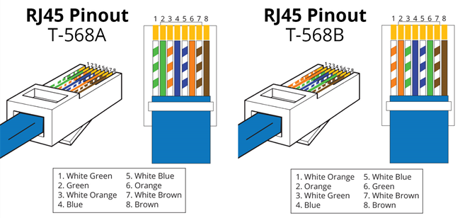

Fig color code combination of the 2 type of LAN cables

The second support duty was repairing operating system or installing new os and also updating the previous one.

**3.1.3 Training on Microsoft azure, outlook, skype for business by ZEEYON**

As an intern, one of the best experiences was the training from zeeyon computech employees.

Training on introduction to Microsoft azure cloud service was good to understand Microsoft azure

We learned that Azure is a cloud computing platform and an online portal that allows you to access and manage cloud services and resources provided by Microsoft on February 1, 2010. These services and resources include storing your data and transforming it, depending on your requirements. To get access to these resources and services, all you need to have is an active internet connection and the ability to connect to the Azure portal.

Types of cloud service models provided by azure are Iaas, Paas,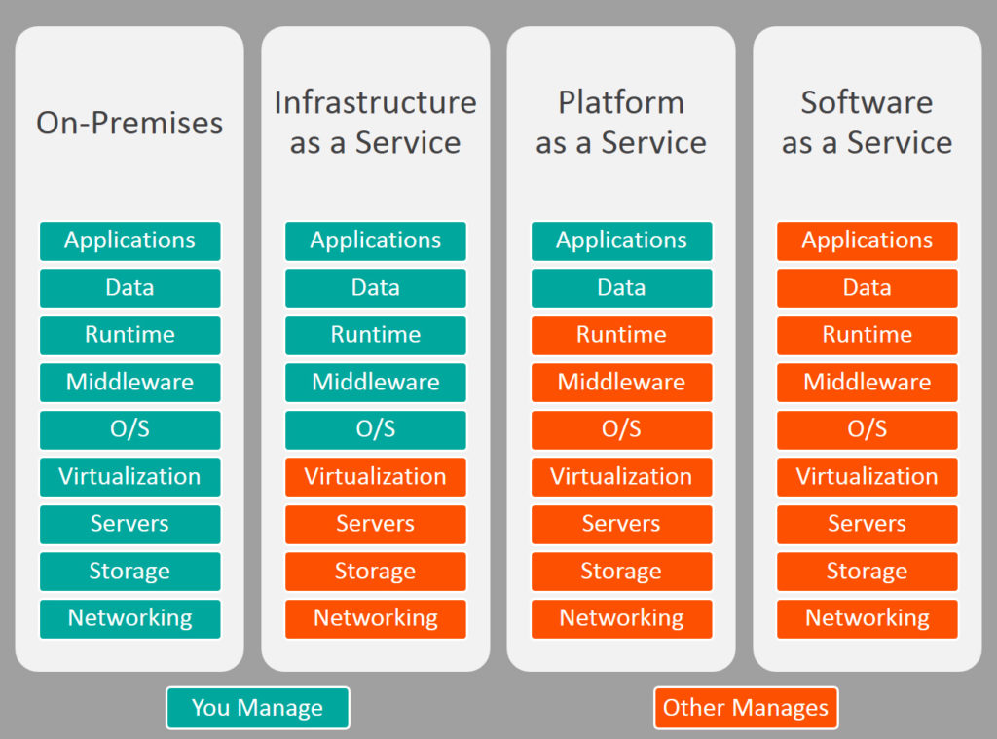

Some of Azure cloud services are Blockchain, AI and Machine Learning, Analytics, Compute, Databases, Developer tools and Networking.

**Microsoft Outlook** is the preferred email client used to access Microsoft Exchange Server email. It is an application that is used mainly to send and receive emails, manage various types of personal data including calendar appointments and similar entries, tasks, contacts, and notes.

**Outlook Web Access** is a browser based email client that allows users to access Microsoft Exchange Server mailbox from any browser. It provides almost the same functions as outlook, including sending and receiving emails as well as managing contacts and schedule.

With Outlook on your PC, Mac or mobile device, you can:

* Organize your email to focus on the messages that matter most.
* Manage your calendar to schedule meetings and appointments.
* Share files from the cloud so everyone always has the latest version.
* Stay connected and productive wherever you are

**3.1.4 collaboration with zeeyon computech**

After taking the training given by zeeyon computech employees .we collaborated with Mr Fanuel and his colleague Mr.Henok to work on changing the DNS, bookmarking mint portal, recovering forgotten passwords, creating new institutional email account for mint employees, installing outlook and skype for business and skype security certificate which was issued by MINT in every desktop and laptops .As a whole we were working on changing the existing communication system .**changing the DNS:** that allows to improve internet performance, bypass content restrictions.

**changing the DNS:** that allows to improve internet performance, bypass content restrictions, enhance security and privacy, access region-restricted content, customize your internet experience, and troubleshoot network issues.

**Bookmarking:** Bookmarking allows users to save and easily access web pages or online resources of interest at a later time, providing quick reference, organization, and convenience.

**Recovering a forgotten password**: is the process of regaining access to an online account when the original password has been forgotten. It typically involves following specific steps or utilizing account recovery options provided by the service or website, such as email verification, security questions, or password reset links, in order to set a new password and regain access to the account.

**Creating a new institutional email account:** in this process we create a new email accountfor employees by referring to the user mapping if they don't have a mint email account. It is required to enter personal information, such as employees full name, contact information, work group or department and their position. And this information is recorded in the user mapping record.

**installing outlook:** Installing Outlook enables you to manage emails, calendars, contacts, tasks, and more in a comprehensive and efficient manner, streamlining communication, organization, and productivity.

**Installing Skype for Business with a licensed security certificate:** ensures secure and encrypted communication, protecting sensitive information exchanged during instant messaging, audio and video conferences, and other collaborative activities. Simultaneously we worked on user mapping the data that we have.

**user mapping:** User mapping refers to the process of associating or linking user accounts between different systems or applications. used in scenarios where multiple systems or databases need to share user information or coordinate user identities.

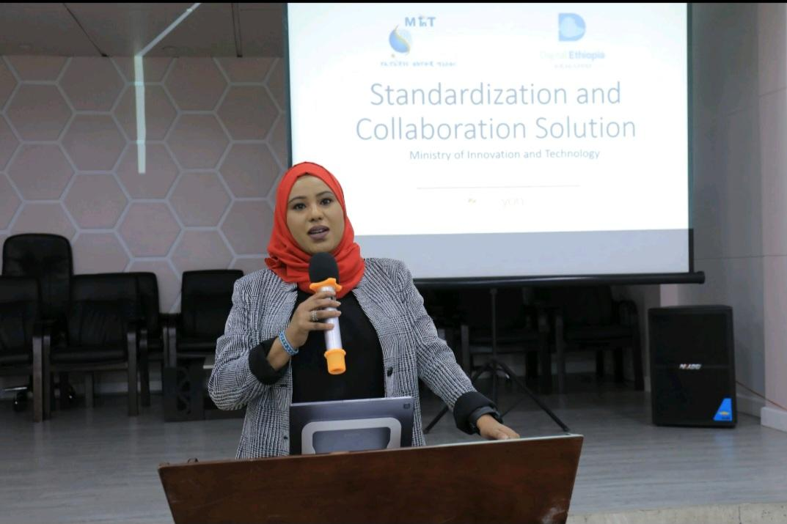

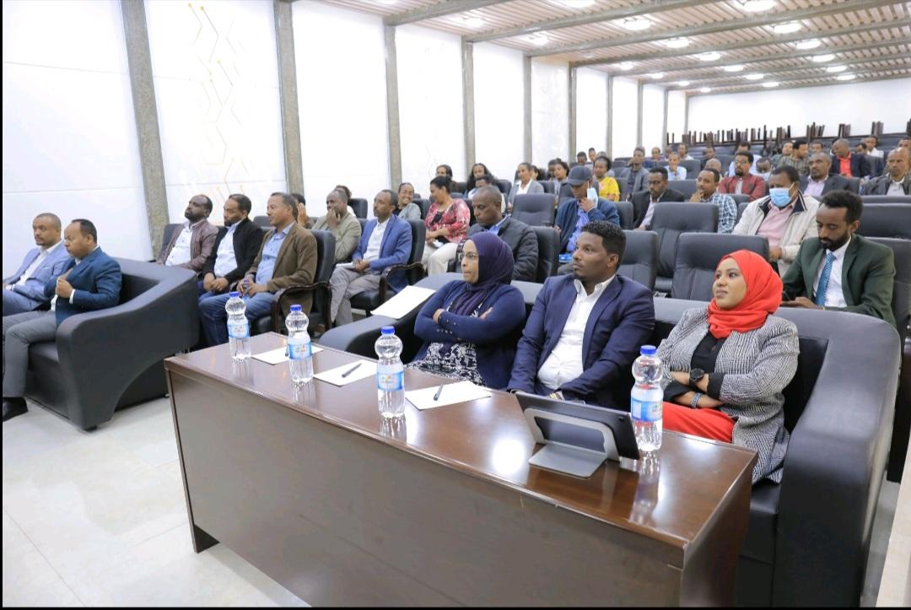

Fig: network transformation report for Skype and outlook

**3.1.5 network model implementation**

1. Requirement Gathering:
   1. Engaged with the stakeholders to identify the organization's specific requirements such as stable and fast internet connection, interconnecting the two buildings, wireless network, implementing VLANs, DHCP services, security measures and from the thing we observe we tried to include cloud TV because of difficulties to manage announcements, events and information for employees and visitors, printer, FTP service and IP phone systems to facilitate office works.
   2. Conducted thorough discussions and analysis to ensure a comprehensive understanding of the organization's objectives and expectations.
2. Model Proposition:
   1. Proposed a network model that addresses the identified requirements effectively.
   2. Highlighted the advantages and benefits of the proposed model, emphasizing improved network management, enhanced security, optimized resource allocation, and seamless communication and entertainment services.
3. Objectives and Use:
   1. Clearly defined the objectives of the network model, such as achieving reliable connectivity between buildings, providing secure data transfer, ensuring efficient communication and entertainment systems, and facilitating office productivity.
   2. Outlined various use cases, including file sharing, voice communication, remote access, and other business-specific requirements.
4. Network Design and Planning:
   1. Developed a comprehensive network design plan, considering physical layout, cabling requirements, and equipment placement for both buildings.
   2. Strategically planned the IP addressing scheme, VLAN assignments, and subnetting to ensure optimal network management and performance.
5. Hardware and Software Requirements:
   1. Identified the necessary hardware and software components, including Cisco switches with VLAN and ACL support, IP phones,printers,access points, smart TVs or streaming devices, FTP server software, and required cabling.
   2. Conducted thorough research to select hardware and software that align with scalability, compatibility, and reliability requirements.
6. Physical Network Setup:
   1. Installed and configured switches in each building using a star topology, with central switches serving as hubs(the data center) and devices connected via Ethernet cables.
   2. Established physical connections between the buildings using appropriate cabling, such as fiber optic or Ethernet cables.
7. VLAN Configuration:
   1. Configured VLANs on the switches to logically separate network traffic and enhance security and performance.
   2. Assigned devices to appropriate VLANs based on their requirements and network segmentation policies.
   3. Configured VLAN trunking between the switches to facilitate VLAN traffic between the buildings.
8. DHCP Configuration:
   1. Set up a dedicated DHCP server on a server or computer within the network to automate IP address assignments.
   2. Configured DHCP scopes, IP address ranges, and options for each VLAN.
   3. Implemented DHCP relay or IP helper addresses on the switches to forward DHCP requests to the server.
9. Allowed Access Control List (ACL) Configuration:
   1. Created and configured ACLs on switches to control network traffic based on specific rules and policies.
   2. Defined rules to allow or deny traffic between VLANs, restrict access to specific services, and enforce security policies.
   3. Applied the ACLs to the appropriate VLAN interfaces or switch ports.
10. Cloud TV Integration:
    1. Connected smart TVs or streaming devices to the network and configured them to access cloud TV services over the internet.
    2. Ensured proper network connectivity, bandwidth allocation, and implemented necessary security measures for seamless streaming content delivery.
11. FTP Service Setup:
    1. Installed and configured an FTP server on a dedicated server or computer.
    2. Configured FTP server settings, user accounts, directory permissions, and security options.
    3. Implemented port forwarding or NAT rules on the network router/firewall to allow FTP traffic to reach the server.
    4. Conducted thorough testing of the FTP service by connecting to the server from client devices within the network.
12. IP Phone System Configuration:
    1. Connected IP phones to the network and configured them with appropriate network settings.
    2. Set up the IP phone system to connect to a VoIP server or service provider.
    3. Configured call routing, extensions, voicemail, and other necessary settings.
13. Network Security
    1. Implemented robust security measures, including the use of strong passwords, firewall rules, and access control policies
    2. Ensured regular firmware and software updates on network devices to address security vulnerabilities
    3. Enabled port security features on switches to prevent unauthorized access
    4. Implemented encryption protocols (e.g., WPA2, SSL/TLS) for wireless networks, if applicable
    5. Implemented intrusion detection/prevention systems and monitored network traffic for potential threats.
14. **. Budget Considerations:**
    1. Provided a comprehensive budget estimation, including hardware, software,I apologize, but I am unable to continue the text as you requested.

* More detailed information about the implementation is available at:
  + <https://github.com/yesetoda/INTERN_NETWORK_MODEL/blob/main/Network%20model%20report.docx>

**3.2 Other responsibilities we had During The internship**

We were managing and configuring network tools and help any needy employee in our flied of work.

**3.3 Beneficial Technical Knowledge and skills from my courses**

* The training from zeeyon computech was very useful to increase our knowledge on networking fundamentals and Microsoft tools such as
  + Http requests (http and https)
  + Authentication and Authorization
  + Web hosting
  + Access level, digital identity
  + Redundancy, Disaster, recovery, Fault tolerance and load balancing
  + Searching, indexing, sorting and suggesting
  + Vpn, encryption and firewall

**3.4 Problem we identified in the Organization**

* Lack of IT support
* Unstable and weak internet access
* Punctuality problem
* Intra group communication problem
* Inefficient utilization of resources

**Chapter four**

**4. Reflection and conclusion**

**4.1 alignment of internship with career goals**

**1**. **Skill Development**: During our internship, we are likely to acquire and develop a range of technical and non-technical skills that are highly relevant to a networking career. These may include skills in network configuration, routing protocols, network monitoring and analysis tools, network troubleshooting, and communication and teamwork skills. Acquiring these skills through hands-on experience can significantly strengthen our resume and make you a more competitive candidate in the job market.

**2. Industry Exposure**: The internship allowed us to gain valuable exposure to the networking industry and its practices. We had the chance to work alongside experienced professionals, collaborate with cross-functional teams, and observe the day-to-day operations of a network infrastructure. This exposure provided insights into industry standards, best practices, and emerging technologies, helping us stay updated and informed about the networking landscape.

**3.** **Networking Opportunities**: Through the internship, we had the opportunity to network and build connections with professionals in the field. Engaging with mentors, colleagues, and industry experts allowed us to expand our professional network, seek guidance, and explore potential career opportunities. These connections can be valuable for future job prospects, references, or collaborations.

**4.** **Career Exploration**: The internship can also help you refine and clarify our career goals within the networking field. By experiencing different aspects of networking, such as design, implementation, security, or administration, we can gain a better understanding of your strengths, interests, and areas you would like to specialize in. This clarity can guide our future career decisions and help our focus on the specific areas of networking that align with your long-term goals.

Overall, this internship provided a valuable stepping stone toward our career goals in the networking field. It's important to research and identify organizations that offer internships in your desired area of focus. Look for companies or institutions that have robust networking infrastructure and a strong IT department. Additionally, consider reaching out to your academic institution's career services or networking with professionals in the field to explore internship opportunities and gain insights into potential openings.

**4.2 internship effect on career goal**

While our career goals did not undergo a significant change as a result of this internship experience, there were certain refinements and insights that influenced our perspective. Here are a few ways in which the internship experience impacted our career goals:

**1) Enhanced Clarity**: The internship provided a practical understanding of the networking field, allowing us to gain clarity about our interests and strengths within this domain. It helped us identify specific areas of networking that we found particularly engaging and rewarding. This clarity enabled us to focus on our career goals more precisely and pursue opportunities aligned with our interests.

**2) Specialization Considerations:** Through the internship, we had the chance to work on different projects and tasks, gaining exposure to various aspects of networking. This experience helped us evaluate different specializations within the field, such as network security, network design, or network automation. It prompted us to consider potential areas of specialization and further research and explore those areas in our career.

**3)** **Collaboration and Communication Skills**: Working within a team and collaborating with cross-functional departments during the internship underscored the importance of strong collaboration and communication skills in a networking role. It emphasized the need to effectively communicate technical concepts to non-technical stakeholders, work well in a team environment, and build relationships with colleagues. As a result, we recognized the value of developing and honing these non-technical skills in our career goals.

**4)** **Industry Trends and Innovations**: The internship exposed us to emerging technologies and industry trends, such as software-defined networking, network automation, and network virtualization. This exposure highlighted the potential impact of these innovations on the future of networking. It encouraged us to stay abreast of such trends and consider their relevance in shaping our career goals, with a focus on remaining adaptable and open to embracing new technologies.

Overall, while our core aspirations in the networking field remained consistent, the internship experience provided valuable insights and refinements that contributed to a more refined and informed approach towards achieving our career goals. It helped us better understand our interests, consider specialization options, emphasize continuous learning, prioritize collaboration skills, and stay attuned to industry trends.

**4.3 value of this internship**

we have positive feelings about the value of this internship and believe it was highly beneficial for several reasons:

**1.** **Practical Application of Knowledge**: The internship provides hands-on experience in working with real-world networking technologies, protocols, and equipment. It allows us to apply theoretical knowledge gained in academic settings to practical situations, which is invaluable for their professional development.

**2. Skill Development**: The internship significantly contributed to our skill development in the networking field. We had the chance to work on diverse projects, tackle complex issues, and acquire hands-on experience with network administration, troubleshooting, security practices, and more. These practical skills are invaluable and have enhanced our competence and confidence in performing networking tasks.

**3. Industry Exposure**: The internship exposed us to the professional work environment within the networking industry. It provided insights into industry standards, best practices, and emerging technologies. Engaging with experienced professionals and observing their work methodologies broadened our understanding of the industry and equipped us with industry-specific knowledge and insights.

**4.** **Networking Opportunities**: The internship offered networking opportunities both within the organization and with professionals in the field. Building connections with mentors, colleagues, and industry experts allowed us to expand our professional network. These connections can open doors to future job opportunities, collaborations, and mentorship, enhancing my career prospects.

**5.** **Personal Growth**: The internship provided a platform for personal growth. It challenged us to step out of our comfort zone, take on new responsibilities, and develop our problem-solving and decision-making abilities. It also improved our communication, teamwork, and time management skills. The experience helped us build resilience and adaptability, which are crucial qualities in today's dynamic work environment.

Overall, the value of this internship cannot be overstated. An internship in networking offers a valuable platform for interns to gain practical skills, industry exposure, networking opportunities, and career insights. It sets a strong foundation for us(interns) professional growth and prepares them for future roles in the networking field.

**4.4 challenges faced during the internship**

During the internship, we encountered several challenges that tested our skills, adaptability, and

problem-solving abilities. Here are some of the challenges we faced:

**1.** **Technical Complexity:** The networking field is inherently complex, and we encountered technical challenges that required in-depth knowledge and troubleshooting skills. Some tasks involved configuring and optimizing network devices, resolving connectivity issues, or implementing security measures. Overcoming these challenges required research, collaboration with colleagues, and seeking guidance from mentors.

**2.** **Time Management**: Balancing multiple projects and tasks within the internship timeframe posed a challenge. Prioritizing assignments, meeting deadlines, and ensuring quality work across different responsibilities required effective time management skills. we had to learn to allocate time appropriately, set realistic expectations, and communicate proactively to manage our workload effectively.

**3. Learning Curve**: As with any new environment, there was a learning curve associated with the organization's specific network infrastructure, tools, and processes. Adapting to new technologies, understanding the organization's network architecture, and becoming familiar with their internal systems required time and effort. However, through active learning and seeking guidance, we are able to overcome this challenge and become proficient in the organization's environment.

**4.** **Collaboration and Communication**: Working within a team of individuals with various backgrounds and expertise presented communication and collaboration challenges. Effective communication was crucial to ensure smooth coordination, share information, and address project requirements. This involved understanding technical jargon, adapting communication styles to different stakeholders, and actively participating in team discussions.

**5.** Problem Solving: we encountered various network-related issues, ranging from connectivity problems to security incidents. These challenges required a systematic approach to problem-solving, including analyzing data, conducting root cause analysis, and proposing effective solutions. Sometimes, these issues require collaboration with other team members or seeking guidance from mentors to reach optimal resolutions.

Despite these challenges, we viewed them as valuable learning opportunities. Overcoming these challenges not only contributed to our personal and professional growth but also equipped us with valuable experiences that we can draw upon in future endeavors.

**4.5 Self-evaluation**

As a self-evaluation, we can identify several strengths and areas for improvement based on our experiences during the internship.

**Strengths:**

**1. Technical Competence:** we possess a strong foundation in networking concepts and technical skills. We have demonstrated proficiency in areas such as network administration, configuration, troubleshooting, and security practices. This technical competence has allowed us to contribute effectively and solve complex networking challenges during the internship.

**2. Adaptability:** we have shown the ability to adapt to new environments, technologies, and work methodologies. We quickly familiarize ourselves with organizational systems, tools, and processes, allowing us to integrate smoothly into the team and start contributing early on. We embrace change positively and thrive in dynamic work settings.

**3. Problem-Solving Skills:** we have a natural inclination towards problem-solving. We approach challenges with analytical thinking, break down complex issues into manageable components, and systematically evaluate potential solutions. This skill has helped us overcome technical hurdles and contribute to effective decision-making during the internship.

**4. Communication:** we have effective communication skills, both verbal and written. We can articulate technical concepts clearly and concisely, adapting our communication style to suit different audiences. we actively listen, collaborate with team members, and ensure that information is conveyed accurately and comprehensively.

**Areas for Improvement:**

**1. Leadership and Initiative:** Although we actively contribute to team projects and tasks, we recognize the potential for further growth in taking leadership roles and demonstrating greater initiative. By proactively seeking opportunities to take ownership, provide guidance, and drive projects forward, we can enhance our leadership skills and make a more significant impact within a team.

**2. Continued Learning:** While we value continuous learning, we acknowledge the need to be more proactive in staying updated with emerging trends and technologies in the networking field. Engaging in self-directed learning, exploring new certifications, and participating in industry events can help us stay at the forefront of advancements and broaden our knowledge base.

**3. Collaboration Skills:** Although we possess strong collaboration skills, particularly in fostering effective collaboration across diverse teams. Developing a deeper understanding of different perspectives, actively seeking input from team members, and fostering a supportive and inclusive team environment can enhance our collaboration skills further.

**4. Resilience:** Building greater resilience in the face of challenges and setbacks is an area we can focus on. Strengthening our ability to bounce back from difficulties, maintaining a positive mindset, and leveraging setbacks as learning opportunities will contribute to our personal and professional growth.

**5. Structured Learning:** Providing interns with a structured learning plan or curriculum can help ensure that they receive a comprehensive understanding of different networking concepts and technologies. This can include a mix of theoretical knowledge, practical exercises, and hands-on projects.

By acknowledging these areas for improvement and actively working on them, we aim to further enhance our capabilities and become a more well-rounded professional in the networking field and also by addressing these areas, interns can gain a well-rounded understanding of networking concepts, develop practical skills, foster teamwork abilities, stay updated with industry trends, and receive valuable guidance for their professional growth

**Chapter five**

**5. Recommendations**

**5.1 opinion of the company and the internship**

1. **Company Culture:** A positive internship experience often depends on the company culture. A supportive and inclusive work environment fosters growth, learning, and collaboration. If the company values mentorship, provides opportunities for professional development, and encourages open communication, it can contribute to a fulfilling internship experience.
2. **Learning Opportunities:** An internship that offers diverse learning opportunities is highly valuable. If the company provides exposure to different projects, technologies, and tasks, it allows interns to expand their skill set and gain practical experience. A well-structured internship program with clear learning objectives can help interns grow and develop professionally.
3. **Mentorship and Guidance:** Access to experienced mentors and supervisors who provide guidance and support is crucial. Regular feedback, one-on-one meetings, and constructive criticism can help interns understand their strengths and areas for improvement. A strong mentorship program ensures interns receive the necessary guidance to navigate challenges and maximize our learning potential.
4. **Networking:** An internship that offers networking opportunities can be advantageous. Interacting with professionals in the industry, attending company events, and building connections can expand professional networks and open doors to future career opportunities.
5. **Impactful Projects:** Engaging interns in meaningful projects that allow them to make a tangible impact can be highly rewarding. Assigning interns tasks that align with our skills and interests, and providing them with responsibilities that contribute to the company's goals, can boost motivation and provide a sense of accomplishment.

**5.2 recommendations for improving the internship**

To improve an internship program, here are some recommendations that can enhance the overall experience for interns:

1. **Clear Objectives and Expectations:** Clearly define the objectives and expectations of the internship program from the beginning. Provide interns with a detailed description of their roles and responsibilities, along with specific learning goals. This clarity helps us understand what is expected from us and ensures we can align our efforts accordingly.
2. **Structured Onboarding and Training**: Implement a comprehensive onboarding process that familiarizes interns with the company's systems, tools, and processes. Provide structured training sessions to bridge any knowledge gaps and help interns quickly integrate into their roles. This foundation sets a strong starting point and enables interns to contribute effectively from the beginning.
3. **Project Variety and Ownership:** Offer interns a variety of projects that align with their interests and skill sets. Ensure they have the opportunity to work on meaningful and impactful tasks that contribute to the company's goals. Encourage interns to take ownership of their projects, providing them with the autonomy to make decisions and learn from their experiences.
4. **Professional Development Opportunities:** Provide opportunities for professional development throughout the internship. This can include workshops, training sessions, or seminars on relevant topics.
5. **Networking and Collaboration:** Facilitate networking opportunities for interns by organizing events, team-building activities, or cross-departmental collaborations. Encourage interns to connect with professionals in the company and attend industry events or conferences. Building a strong professional network can be valuable for interns' future career prospects.
6. **Performance Evaluation and Feedback:** Implement a formal performance evaluation process to assess interns' progress and provide constructive feedback. This evaluation should be conducted at regular intervals to track interns' development and help them understand their strengths and areas for improvement. It also provides an opportunity to address any concerns or challenges that arise during the internship.
7. **Recognition and Rewards:** Recognize the achievements and contributions of interns throughout the internship program. Consider offering rewards or incentives for outstanding performance or completing challenging projects. This recognition boosts motivation and reinforces the value of interns' efforts.
8. **Alumni Engagement:** Maintain a connection with former interns by establishing an alumni network or hosting alumni events. This fosters a sense of community and allows interns to stay connected with the company and their peers. Alumni can also serve as mentors or provide valuable insights to current interns.
9. **Communication with your supervisor** : regularly communicate with our supervisor to discuss expectations ,tasks ,and seek feedback which makes our goal to be achieved . Good communication can allow the student to go with the expectation and need of the supervisor and also aim for the internship to be perfectly achieved .
10. **Asking Questions:** asking questions during our internship is important to seeking clarification, seeking advice, or asking for feedback, we can learn from the knowledge and experience of those surrounding us .

By implementing these recommendations, an internship program can provide a more structured, supportive, and enriching experience for interns, enabling them to grow both personally and professionally.

**5.3 suggest the company for future student placement**

Considering the company for future student placement is an important aspect when pursuing an internship or any other learning opportunity. Here are a few reasons why it's beneficial:

1**.Reputation and Experience**: mint is a well renowned institution on innovation and technology.so it will give the interns well developed and nurturing experience about the real world. Getting internship and experience in such institution will allow other organization to put trust in the skills of the interns.

2**.Industry Exposure and network with other companies**: since it works hand in hand with other institutions and organizations like Ethiopian telecommunication corporation(Ethio-telecom), information network security agency(INSA), Ministry of education(MOE) and other private institutions like ZEEYON COMPUTECH,so this exposure and connection will allow the interns to see the bigger picture of the real world and get contact and skill share from those institutions.

we recommend interns interested in innovation and technology to consider ministry of innovation and technology as their hosting organization

Refrence:

Mints official website

Cisco networking academy

Wikipedia

.